

Of Time and Space and _CopyBits
Imaging M.IM.TimeSpaceCopyBits

Written by: Forrest Tanaka June 1990

This Technical Note describes the various factors that can influence the speed of _CopyBits so that developers can set up conditions to achieve the best performance for the particular situation.

Can You Influence the Speed of _CopyBits?

_CopyBits has never been an “easy” QuickDraw routine, like _LineTo or even _OpenPort. Most programmers who are just beginning to adjust themselves to the Macintosh usually have to give _CopyBits a few tries before the right bits copy to the right places. Even many who feel that they have become Macintosh programmers still see reflections in their monitors of furrows between their eyebrows as they begin to press the key labelled “C.”

_CopyBits is one of those routines that is so full of subtlety, it has the beginnings of something that could be considered to be personality. One subtlety involves the second most important thought that’s on the minds of any computer programmer: execution speed. Why is _CopyBits fast? Why is it slow? Can I influence its speed? Is there really a clandestine state of reason? Is there a price to speed?

Influences on the Speed of _CopyBits

Yes, you can influence the speed of _CopyBits. Yes, it’s even predictable. And yes, it’s possible that you have to compromise to get the maximum speed. This Note is intended to give you a deeper understanding of the ways that the speed of _CopyBits can be affected; and hopefully you can then set up conditions for a _CopyBits call without the disturbing notion that someone else might be doing the same thing just a little bit better than you.

This Note talks about every factor that affects the speed of _CopyBits that I can think of and that can be reasonably controlled by a programmer or the person using an application. There are other factors not mentioned in this Note because I felt that they were just too esoteric to describe with any meaning.

In each case, this Note tries to give real-life examples showing the effect of each factor. These examples are just to give you a relative idea of the importance of each effect. In real life, the effects of the different factors give results that could be a lot different from the results presented in this Note. Each example is based on 100 _CopyBits calls from an off-screen pixel map to
the screen on a Macintosh IIcx with an Apple Extended Video Card which is running System Software 6.0.5 and 32-Bit QuickDraw 1.2. The off-screen pixel map is eight bits deep with the standard eight-bit color table and 256 pixels high by 256 pixels wide. The screen is also in eight-bit color mode. Calling _CopyBits to copy the entire off-screen pixel map to the screen 100 times takes 204 ticks, and this Note refers to this figure as the “standard test.” Since a tick on a Macintosh is approximately 1/60 of a second, the standard test runs at slightly less than 30 frames per second. As this Note discusses each factor, it presents an example with that factor changing and all other factors remaining the same as the standard test, which allows you to compare performance of the changed factor to that of the standard test of 204 ticks.

What follows is a discussion of each factor that can influence the speed of _CopyBits, in no particular order.

Dimensions of the Copied Area

One of the most obvious factors has to do with the dimensions of the copied area. _CopyBits takes as parameters two rectangles which specify the portion of the source pixel map from which you want to copy and the portion of the destination pixel map to which you want to copy it. All other factors being equal, the larger the rectangles, the more pixels _CopyBits has to copy and the longer it takes to do the job. To keep _CopyBits as fast as possible, copy the smallest rectangle possible.

Modifying the standard test so that _CopyBits only copies a 128-pixel wide by 128-pixel tall area produces a result of 109 ticks, which compares to the 204 tick performance for a 256-pixel wide by 256-pixel tall area.

QuickDraw is usually faster drawing wide things than it is drawing tall things, because consecutive pixels in memory are displayed horizontally. Drawing a series of pixels that are next to each other horizontally is easy because QuickDraw simply has to set consecutive memory locations, while drawing a series of pixels that are next to each other vertically is just a little bit harder because the address of each pixel must be calculated. _CopyBits is no exception to this general rule; it copies a row of pixels, goes to the next row, copies that row, goes to the next row, and so on. The time spent going between rows is a lot more than the time going between pixels on one row, so the effect is that _CopyBits is faster copying a short and wide section of a pixel map than it is copying a tall and narrow one. To keep _CopyBits as fast as possible, copy the shortest rectangle possible.

Modifying the standard test again so that the source and destination rectangles are 256 pixels wide by 50 pixels tall produces a result of 110 ticks, while modifying it so that the source and destination rectangles are 50 pixels wide by 256 pixels tall results in a time of 123 ticks. These 13 ticks may not seem like a big deal, but combined with other factors, there may be a case where they make a big difference.

Shape and Size of the Clip, Visible, and Mask Regions

_CopyBits always makes sure that it stays within the lines, so to speak. _CopyBits copies pixels clipped to the maskRgn that you pass as the last parameter to the call. If the destination is the current GrafPort, _CopyBits additionally clips to a region that’s the intersection of the clipRgn and visRgn of the port. If the intersection of these three regions is not rectangular, then _CopyBits has to check each pixel to make sure it falls within the
intersection, and this check slows _CopyBits down. If the intersection of these three regions is rectangular, then _CopyBits takes the fast case of copying constant-sized rows. To keep _CopyBits as fast as possible, make sure the intersection of the clipRgn and visRgn of the destination GrafPort and the maskRgn is rectangular. Of course, if the destination GrafPort is a window, then the visRgn is under the user’s control.

In general, if the region that you are copying into has straight vertical edges for the most part, the time penalty of using a non-rectangular region is not that bad. Regions that only have small portions that are straight and vertical are the ones that slow _CopyBits down in a big way. Regions that are twisted or that have holes or islands can also have a big effect upon the speed, depending upon how complicated they are. As a rule of thumb, if a region looks like it slows _CopyBits, it probably does.

Modifying the standard test so the maskRgn is set to a circle that inscribes the example pixel map results in a time of 303 ticks, which is considerably longer than the standard test result of 204 ticks that involved copying a much larger area. Modifying the maskRgn to a square with 226 pixels per side, which has about the same total area of the circle just used, results in a time of 176 ticks.

Transfer Modes

Macintoshes without Color QuickDraw have eight transfer modes that work with _CopyBits, while those Macintoshes with Color QuickDraw get an additional nine modes. Because the algorithms for each of these modes can be pretty different from the others, the time it takes _CopyBits to work with each of these modes can vary radically. For several of these modes, the speed of _CopyBits can vary a lot depending upon the particular image being copied and the image over which this image is copied. It can also vary non-linearly depending upon the depth of the pixel maps. The arithmetic modes in particular are highly optimized for 32-bit deep pixel maps.

The standard test copies a fairly average-looking ray-traced image to a white background. Modifying the standard test to erase the background between each of the 100 calls to _CopyBits produced the following results for the modes listed (the tests were obviously also changed to reflect the proper mode. In addition, to make the results a little more meaningful, the time it took to erase the background has been subtracted from each result.

srcCopy 204 notSrcCopy 469 addOver 1500 adMax 1504
srcOr 436 notSrcOr 444 addPin 1514 adMin 1501
srcBic 441 notSrcBic 441 subOver 1493 blend 1553
srcXor 438 notSrcXor 436 subPin 1525 transparent 1107
hilite 3127

Of course, the amount of time taken by some of these modes can be changed by changing the image to copy and the image over which it is copied. These figures are just to give an idea of how fast or slow some of these modes are in this particular situation.

There is actually one more mode which is not mentioned: ditherCopy. Apple introduced this mode with 32-Bit QuickDraw, and it makes _CopyBits do error-diffusion dithering when copying a pixel map from one depth to a pixel map of a lesser depth or to a pixel map of the same depth with a different color table. The speed of this transfer mode can be very fast or very slow, depending upon what pixel depths and colors are used and the particular image being copied. The ditherCopy mode is not included in the table since the range of figures is
potentially very large; play with it and see for yourself. For more information about this mode, refer to the Color QuickDraw chapter in Inside Macintosh, Volume VI and the 32-Bit QuickDraw Developers’ Notes from APDA.

Colorization

There is a variation of _CopyBits if the destination pixel map is the current port and the foreground color is not black or the background color is not white. If this is the case, then the source image is colorized when it’s copied. For details, see Technical Note #163, Adding Color with _CopyBits. Because this colorization requires extra processing, _CopyBits slows down. To keep _CopyBits as fast as possible, make sure the foreground color is black, the background color is white, and that the current GDevice pixel map’s color table has white in the first position and black in the last position.

Modifying the standard test so that the foreground color is pure red and the background color pure blue produces a result of 579 ticks.

Pixel Alignment

The alignment of pixels in the source pixel map relative to their alignment the destination pixel map can be surprisingly important to the speed of _CopyBits, but what is pixel alignment? Following is an example to demonstrate the concept of pixel alignment. Imagine you want to perform a _CopyBits on a one-bit-per-pixel off-screen pixel map into a window on a one-bit-per-pixel screen, and the window is three pixels from the left edge of the screen.

If you copy the entire off-screen pixel map to the left edge of the window, then _CopyBits must realign the pixels. Since the leftmost pixels of the off-screen pixel map are on a byte boundary, but the left edge of the window is three pixels away from a byte boundary, _CopyBits has to shift (or realign) each byte from the off-screen pixel map by three pixels before placing it on the screen. The process of aligning the pixels slows down _CopyBits.

Figure 1 shows an example of this realignment. An off-screen bit map specified by a pointer to a BitMap called offScreen is being copied to a window specified by a WindowPtr called window. window, which is 256 pixels wide and 256 pixels high, is positioned 50 pixels from the top of the screen and three pixels from the left edge of the screen. The screen has 512 pixels horizontally and 342 pixels vertically. The source rectangle that is passed to _CopyBits is sourceRect and the destination rectangle is destinationRect. Because offScreen is misaligned by three pixels, _CopyBits has to shift offScreen by three pixels before placing the image on the screen.
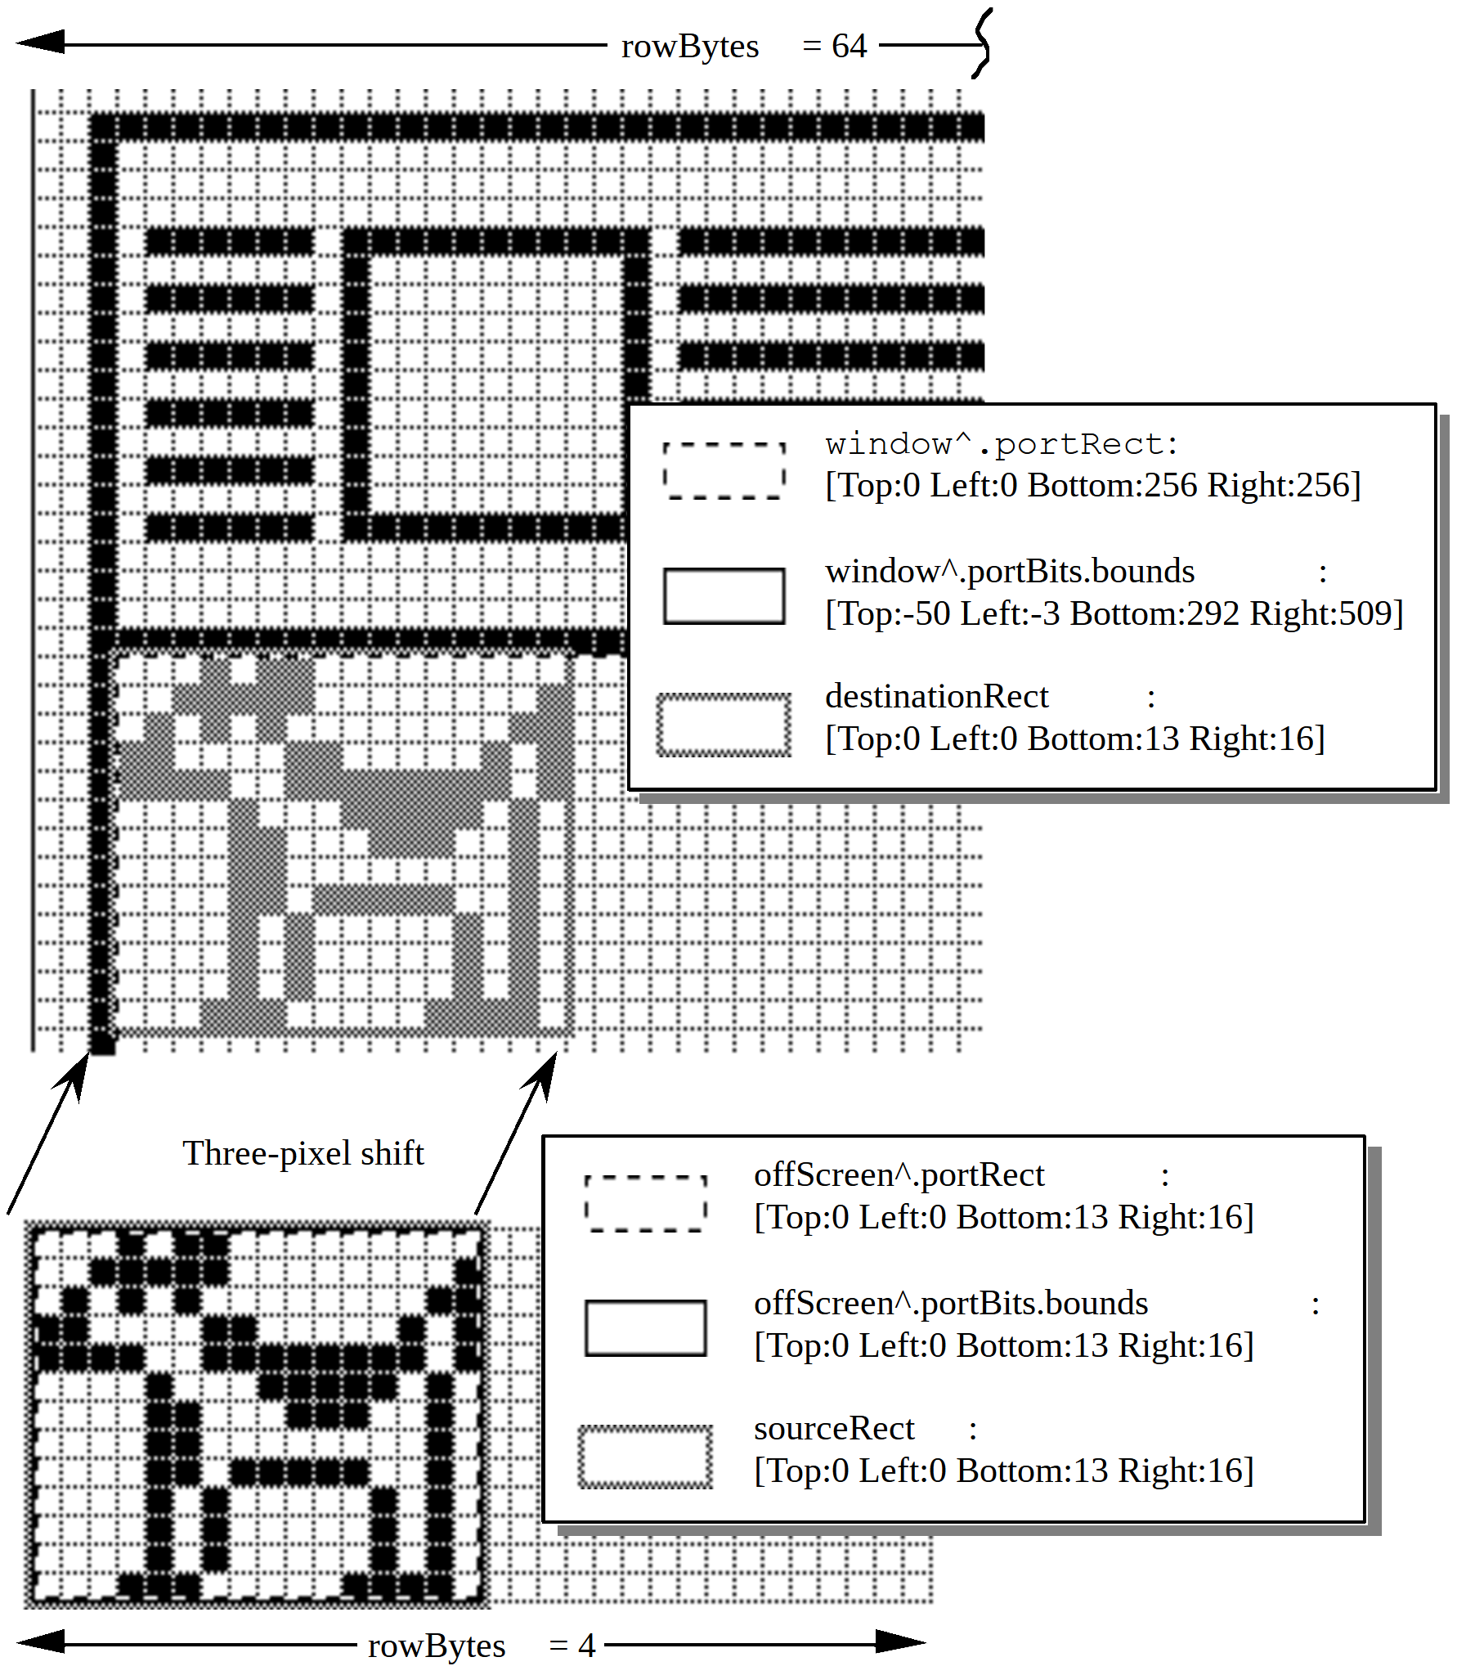

Figure 1–offscreen Needs Realignment

By adjusting the off-screen pixel map so that its leftmost pixels are also three pixels away from a byte boundary, _CopyBits can just copy the bytes without shifting, which is a lot faster. This example holds true on all Macintosh models, whether they have Color QuickDraw or not. To keep _CopyBits as fast as possible, make sure the pixels in memory are aligned with the pixels on the screen. Figure 2 shows the same situation as Figure 1, except that offScreen is now properly aligned to window.

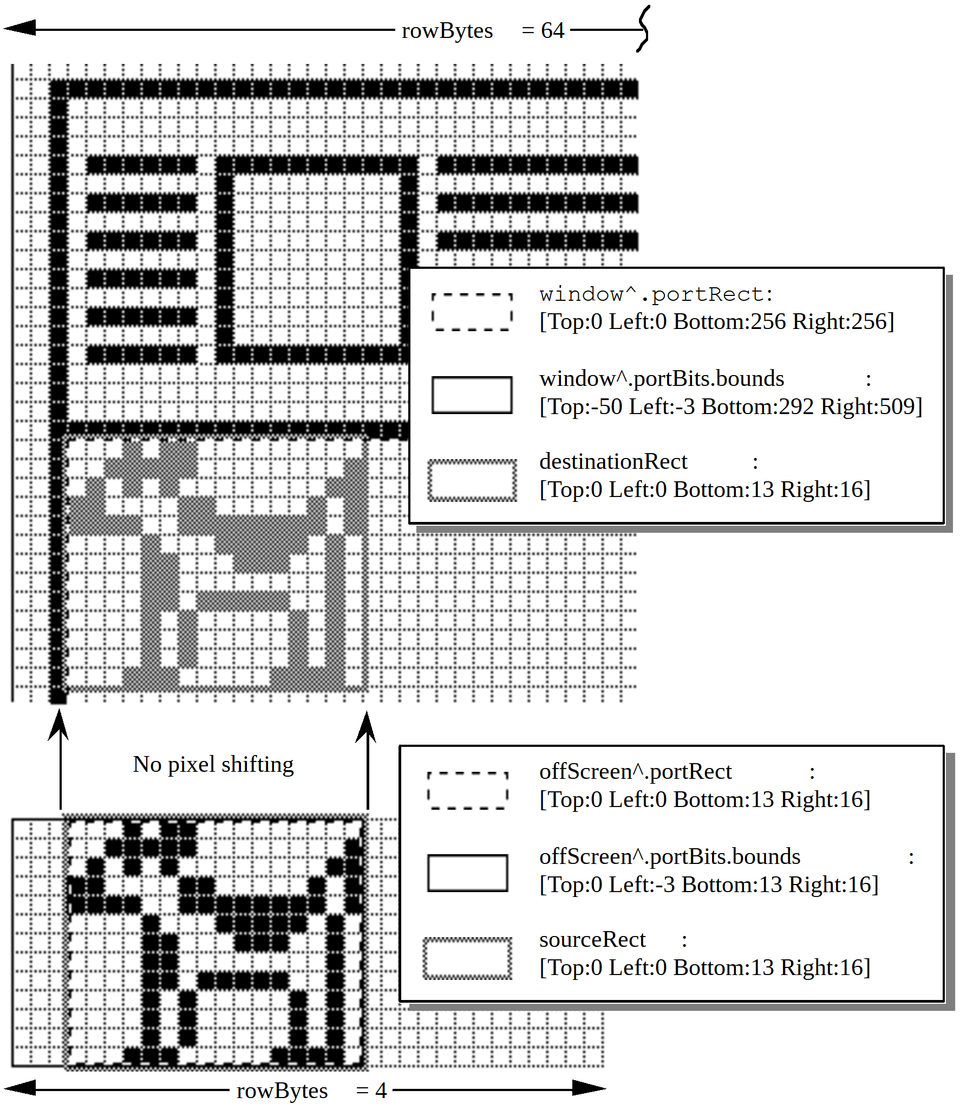

Figure 2–offscreen Aligned

Many, if not most, Color QuickDraw Macintoshes have video cards that can display one pixel per byte, so one would think that pixel alignment does not apply in these cases, since all pixels are at byte boundaries. This statement is true enough, but there is still another kind of alignment that should be done on these machines. Macintoshes with Color QuickDraw generally have full 32-bit microprocessors, and these microprocessors are at their fastest when they can transfer long words aligned on long-word boundaries in memory.

Modifying the last example so that the off-screen pixel map and the screen are both eight-bits-per-pixel, the pixel at the extreme top left corner of the off-screen pixel map is located at a long-word boundary, because the Macintosh Memory Manager forces it to be located there; however, the pixel at the extreme top left corner of the window is located three bytes away from the previous long-word boundary. No bit shifting is needed, because each pixel takes up
a whole byte, but _CopyBits does have to take the non-optimum case of copying long words on non-long-word boundaries. This case works fine, but it is not quite as fast as it could be. To keep _CopyBits as fast as possible, make sure pixels in the source and destination pixel maps are aligned on long-word boundaries.

Since 1984, Macintosh programmers have been told that rowBytes must be even. That is still true, but to allow _CopyBits to copy an entire pixel map on long-word boundaries, rowBytes must be a multiple of four so that every line in a pixel map begins on a long-word boundary. The following formula can be used to find the minimum rowBytes needed for a pixel map’s bounds rectangle with right and left coordinates of bounds.right and bounds.left, and a pixel depth of pixelDepth:

rowBytes := ((pixelDepth * (bounds.right - bounds.left) + 31) DIV 32) * 4;

Off-screen GWorld support, which was introduced with 32-Bit QuickDraw, can automatically set up a pixel map so that it’s properly aligned to any part of the destination pixel map or bit map. You can specify that you want this by passing zero for the pixel depth and passing the rectangle of the destination area in global coordinates. See the 32-Bit QuickDraw Developers’ Notes and “Braving Offscreen Worlds” in d e v e l o p, January 1990 for details.

The way that _NewGWorld aligns a GWorld is to set up the off-screen pixel map so that its rowBytes is four bytes wider than one would normally calculate. Four bytes is the maximum amount that any pixel map would have to be realigned at any pixel depth. The bounds rectangle’s left coordinate is set to the negative of the left coordinate of the destination rectangle in global coordinates modulo (32 / pixel depth), because this is maximum amount that a pixel map must be shifted to achieve perfect alignment. To build on the earlier example, assume you have a 128-pixel wide, eight-bit deep, off-screen pixel map to copy to a window that is three pixels away from the left edge of an eight-bit color screen.

First, the rowBytes for the off-screen pixel map is set to 131 to allow room for realignment. To align the off-screen pixel map to the on-screen window, the left coordinate of the off-screen bit map’s bounds is set to -3 and the right coordinate is still at 128. Notice that the off-screen pixel map’s bounds is now 131 pixels wide. Now, the pixels in the off-screen pixel map with a horizontal coordinate of 0 are located three bytes away from the previous long-word boundary. The pixels on the left edge of the window are also located three bytes away from the previous long-word boundary, so _CopyBits can copy long words on long-word boundaries.

If a user moves the window so that it’s two pixels from the left edge of the screen, the off-screen pixel map must be realigned. _UpdateGWorld is used to do this. It changes the left coordinate of the off-screen pixel map’s bounds rectangle to -2 and then it shifts all the pixels in the off-screen pixel map one pixel to the left. The extra four bytes in each row provide the room for this shifting. (Gives you some new respect for the off-screen support, doesn’t it?)

This same discussion applies to any pixel depth, though shallower pixel depths require bit shifting rather than byte shifting. The same principles apply, though. Notice that in a 32-bit deep pixel map, all pixels are aligned on long-word boundaries, so no bit shifting or byte shifting ever needs to be done on one of those. _NewGWorld still adds four to rowBytes even in this case, however.

Modifying the standard test so that the source and destination pixel maps are four bits deep with perfect pixel alignment produces a result of 78 ticks; however, if the destination pixel map is one pixel left of perfect alignment, the result is 228 ticks.

Speed of the Hardware, Of Course

Obviously, the speed of the machine your application is running on affects the speed of _CopyBits. To make _CopyBits as fast as possible, spend a lot of money. However, there is more to the speed of _CopyBits than the speed of the Macintosh itself. When the Macintosh 128K was released, there was only one place for pixel images: main memory. Today, the situation is more complicated. If you have a modular Macintosh, the pixel image for the screen is in the memory of a NuBus™ video card. If you have a Macintosh IIci, you can optionally abandon the NuBus video card and use on-board video which takes up part of main memory. If you have an 8•24 GC card with enough memory, the pixel images can be cached in the card’s memory along with the screen’s pixel image.

All of these different locations have different access speeds, and that can affect the speed of _CopyBits. Additionally, different Macintoshes have different RAM access speeds. The Macintosh II, IIx, IIcx, and SE/30 have faster RAM than the Macintosh Plus or SE. The Macintosh IIci RAM access speed is faster still, and the Macintosh IIfx has faster RAM access than the IIci. Different video cards have different access speeds. The IIci has a cache card option which can vastly speed up on-board video RAM access speed. Third-party video cards that work in the Processor Direct Slot of the Macintosh SE and SE/30 have their own speed characteristics as well.

There can also be a speed cost for crossing the different areas. If _CopyBits copies between main memory and a NuBus video card, the image data has to be transferred across NuBus. NuBus is a speed bottleneck, so copying an image across NuBus is slower than copying the image from one part of the screen to another or copying from one part of main memory to another. Modifying the standard test to create two windows and two off-screen pixel maps—all eight bits deep with the standard color table then doing every combination of copying between off-screens, between windows, and between off-screens and windows produces the following results:

Off-screen to off-screen: 147
Screen to screen: 188
Off-screen to screen: 204
Screen to off-screen: 201

Performing the standard test on a Macintosh IIfx running System Software 6.0.5 with an Apple Extended Video Card yields a result of 153 ticks, which is not too shabby considering that the transfer is still going through NuBus.

Depth of Pixel Maps

This factor is pretty obvious and is sort of similar to the effect of the dimensions of the copied area: the more bits per pixel there are in the pixel map to copy, the more memory that _CopyBits has to move and the longer it takes to get the job done, assuming that the source and destination pixel maps have the same depth. To make _CopyBits as fast as possible, make sure the pixel maps are as shallow as possible.

If _CopyBits has to copy to a pixel map that has a different depth from the source pixel map, the relationship between speed and depth becomes more complicated. There is a tradeoff between the time taken to change the depth of an image and the absolute amount of data that has
to be processed. Copying from a 1-bit deep pixel map to a 32-bit deep pixel map is not that slow because the amount of image data in the 1-bit deep pixel map is so small.

Modifying the standard test to transfer a four-bit deep pixel map to another four-bit deep pixel map produces a result of 78 ticks.

Color Mapping

Color QuickDraw expects a color table attached to every indexed pixel map. Color tables specify what color each pixel value in the pixel map represents. When an application calls _CopyBits to copy a pixel map into another pixel map, _CopyBits reproduces the colors of the image in the source pixel map as closely as possible—even if the colors available in the destination pixel map are different than those available in the source pixel map. This reproduction is done through a process called “color mapping.”

When color mapping is done, the source pixel values are transformed into RGBColor records using the source pixel map’s color table. These RGBColor records are passed to _Color2Index which finds the pixel values of the closest available colors in the current GDevice pixel map’s color table. This same process is done when the source and destination pixel maps have differing depths. The color table attached to the destination pixel map is not used in color mapping. The colors available in the current GDevice pixel map’s color table are used instead. So, the destination pixel map must have the same colors for the same pixel values as the current GDevice. Otherwise, the resulting image in the destination pixel map gets the wrong colors. See Inside Macintosh, Volume V-141, The Color Manager, for a description of _Color2Index. It’s also helpful to read the “Inverse Tables” section in the same chapter on page V-137.

Now, if the source color table contains virtually the same colors for the same pixel values as the current GDevice pixel map’s color table, then any particular pixel value has the same color regardless of whether it is in the source or destination pixel map. In this case, color mapping is a waste of time, because the pixels can be copied directly from the source pixel map to the destination pixel map without a loss of color fidelity. _CopyBits takes advantage of this special case to yield some big speed improvements. How is this special case detected? Before this question is answered, it’s useful to understand how Color QuickDraw uses color tables.

The ctSeed Field

The first field in a color table is the ctSeed field. This LongInt can be thought of as the color table’s version of the scrapCount field of the desk scrap. Whenever an application calls _ZeroScrap, the desk scrap’s scrapCount is changed. An application can tell that the desk scrap has changed by checking to see if the scrapCount has changed. Similarly, whenever the contents of a color table are changed in any way, the ctSeed field should be changed to indicate to anyone using that color table that it has been modified.

Additionally, Color QuickDraw often uses the ctSeed as a fast check for color table equality. If two color tables have the same ctSeed, then Color QuickDraw often assumes that their contents are equivalent.

After creating a new color table, an application has to get a valid value for the ctSeed field, and it can do so with the _GetCTSeed routine. This routine generates a valid ctSeed value
suitable for a new color table. See Inside Macintosh, Volume V-143, The Color Manager, for a description of _GetCTSeed.

System Software 7.0 and 32-Bit QuickDraw each offer a routine called _CTabChanged which should be called after a color table is modified. It takes a handle to the changed color table as a parameter. If the _CTabChanged routine is not available, then the application should instead change ctSeed to a different valid value by calling _GetCTSeed and assigning the result to ctSeed, just like it’s done when the application creates a new color table. You must use either one of these methods to tell Color QuickDraw that the color table has changed, or else the modified color table could be confused with the old color table, or with some other color table—this is especially critical if an 8•24 GC card is being used. See the 32-Bit QuickDraw Developers’ Notes for details about the _CTabChanged routine.

The ctFlags Field

The ctFlags field is used as a set of flags that indicate some characteristics of the color table. Currently, only the top two bits of ctFlags are of any interest to developers. The most significant bit of ctFlags (bit 15) indicates whether the color table is a sequential color table or an indexed color table. Bit 14 indicates that the color table is a special kind of sequential table if it is set. In these kinds of color tables, the value fields indicate a palette entry in the destination window’s palette. See the Palette Manager section of the 32-Bit QuickDraw Developers’ Notes for a discussion about this capability.

Sequential Color Tables

If bit 15 of ctFlags is set, the color table is a sequential color table. Sequential color tables are usually found attached to GDevice pixel maps and to GWorld pixel maps.

In sequential color tables, the position of each color in the color table indicates the pixel value to which it corresponds. For example, the fifth entry in a sequential color table always has a pixel value of four (pixel values start at zero). The value field of each ColorSpec is not defined in sequential color tables, though they are used in color tables for screen GDevice records to indicate that a particular color is reserved, protected, or both.

Indexed Color Tables

If bit 15 and 14 of ctFlags are clear, the color table is an indexed color table. In indexed color tables, the value field of each ColorSpec indicates the pixel value of the RGB in that ColorSpec. For example, if the fifth ColorSpec in the color table has a value field containing 10, then that color has a pixel value of 10, not 4, as it would have been if this were a sequential color table.

Color Mapping or Non-Color Mapping

As noted before, _CopyBits can detect whether it has to do color mapping or not, so that it can take advantage of the speed benefits of no color mapping if possible. How is this done? First, _CopyBits checks to see if the ctSeed field of the source and destination color tables are the same and if the source and destination pixel maps have the same depths. If both of these conditions are true, then _CopyBits assumes that the two color tables are identical and it just copies the pixels directly without color mapping. If the ctSeed fields are different, _CopyBits checks manually through all of the colors in the source pixel map’s color table
map to see if they map to the same pixel values in the current GDevice pixel map’s color table as they do in their own color table. If they do, then _CopyBits again takes the fast case.

So to keep _CopyBits as fast as possible, make sure that the source and destination color tables have virtually the same colors for the same pixel values. This applies even if one color table is an indexed color table and the other is a sequential color table, or if the source and destination color tables are both indexed but the order of the ColorSpec records differ.

Modifying the standard test so that the source pixel map has a color table that is the reverse of the standard eight-bit system color table (the grays have low pixel values and the light pinks and yellows have high pixel values) and the destination pixel map has the standard eight-bit system color table produces a result of 470 ticks.

By the way, color tables do not make any sense for direct pixel maps, so this discussion does not apply to them. Direct pixel maps do have a color table attached to them, but they’re just there so that an application that assumes that a color table is attached does not bomb.

Scaling

If the source and destination rectangles are the same size, _CopyBits has the fairly easy task of just transferring the pixels from the source pixel map to the destination pixel map; however, if the source and destination rectangles are different sizes, _CopyBits has to scale the copied image, which slows it down a lot. To keep _CopyBits as fast as possible, make sure the source and destination rectangles have the exact same dimensions.

Modifying the standard test to copy a 128 by 128 pixel portion of the source pixel map to the whole 256 by 256 pixel window produces a result of 1,159 ticks.

Of Time and Space

Hopefully, this Note makes it a lot clearer to you how to set up a situation in which your _CopyBits calls are as fast as your situation allows. It’s important to realize that this Note does not cover every single factor that has an influence on the speed of _CopyBits. There are many more factors which are just too unpredictable. For example, _CopyBits is highly optimized for many special cases, and those optimizations can have a big effect on the speed of the copy. Also, the speed of _CopyBits can be affected by interrupt-level tasks. It’s up to you to fine tune your programs to your particular situations.

Further Reference:
• Inside Macintosh, Volume I, QuickDraw
• Inside Macintosh, Volume V, The Color Manager
• Inside Macintosh, Volume VI, Color QuickDraw
• Technical Note M.IM.ColorCopyBits, Adding Color With _CopyBits
• d e v e l o p, January 1990, “Realistic Color for Real-World Applications”
• d e v e l o p, January 1990, “Braving Offscreen GWorlds”
• 32-Bit QuickDraw Developers’ Notes (APDA)

NuBus is a trademark of Texas Instruments

